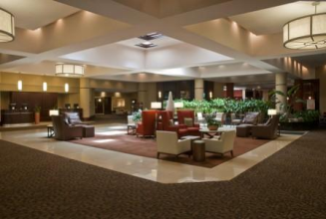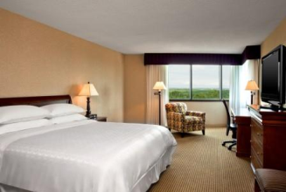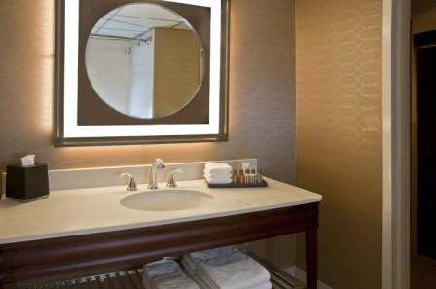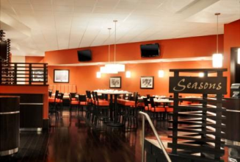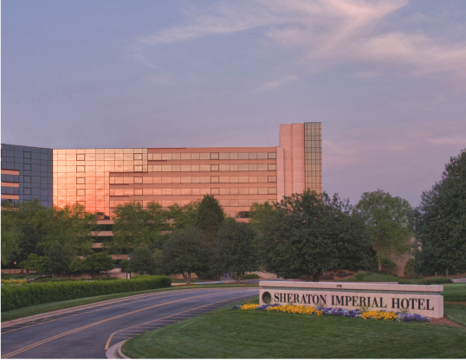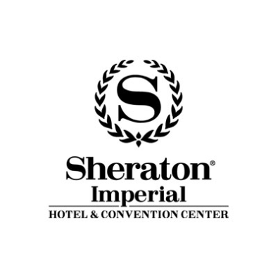

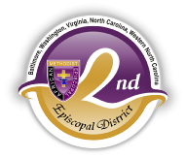
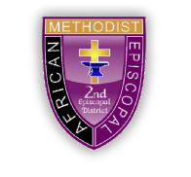

TIME TO MAKE YOUR
RESERVATIONS!

AFRICAN METHODIST EPISCOPAL CHURCH
SECOND EPISCOPAL DISTRICT
Western North Carolina Annual Conference
May 24, 2016: WMS Annual Day
May 25-27, 2016: Annual Conference
May 28, 2016: YPD Annual Day

Hotel Level Guest Room: $109.00 (plus tax)
Make your reservation by copying and pasting the following link into a web browser: https://www.starwoodmeeting.com/Book/WNCCConference2016
Or call 1-800-325-3535 and ask for “Western NC Conference” Room Block
Group rate available until April 23, 2016. Subject to Availability.

Rev. Dr. Byron J. Grayson, Conference Coordinator
Rev. Dr. Conrad K. Pridgen, Host Presiding Elder
Rev. J. Bernard Wilder, Host Presiding Elder

4700 Emperor Blvd. | Durham, North Carolina 27703

Phone: 919-941-5050 | Fax: 919-941-2958 | sheraton.com/imperial

